**THESIS TOPIC: CFD IN SOLIDIFICATION**

**PROFESSOR NAME: VIRKESHWAR KUMAR**

NAME: JANGA RAKESH KUMAR

ROLL NO: 208070466

* **Task – 1**: Finding interface position of solid and liquid after 10 sec of solidification of Aluminum in Graphite mold.

**Finding Φ using secant method and then finding interface position at t=10 sec.**

% Secant method

% initialization

it = 11;

xr = zeros(it,1);

er = zeros(it-2,1);

iter = 0:1:it-1;

f = zeros(it,1);

xr(1)= 0;

xr(2)=0.1;

% constants

T0=25; Tinf=700; Tf=660;

rhom=2200; rhos=2555; rhol=2368;

cpm=1700; cps=1190; cpl=1090;

km=100; ks=211; kl=91;

lf=3.98*10^5;

alpham=km/(rhom*cpm); alphas=ks/(rhos*cps); alphal=kl/(rhol*cpl);

ste=cps*(Tf-T0)/lf; %stefan constant

fun =@(xr) ( xr*exp(xr^2)-cps*(Tinf-Tf)*exp((1-alphas/alphal)*xr^2)*sqrt(kl*rhol*cpl/(ks*rhos*cps))/(lf*sqrt(pi)*erfc(xr*sqrt(alphas/alphal))) )*(erf(xr)+sqrt(ks*rhos*cps/(km*rhom*cpm)));

for i = 3:it

f(i-2) = fun(xr(i-2))-ste/sqrt(pi); % f(i-2)

f(i-1) = fun(xr(i-1))-ste/sqrt(pi); %f(i-1)

xr(i)=xr(i-1)-(f(i-1)*(xr(i-2) - xr(i-1))/(f(i-2) -f(i-1)));

er(i-2) = abs((xr(i) - xr(i-1))/xr(i))*100;

end

figure;

yyaxis left;

plot(iter,xr);

xlabel('iterations');

ylabel('Xr');

title('convergence with Scent method');

yyaxis right;

plot(iter(3:end),er);

set(gca,'Yscale','log');

ylabel('error');

Tms = ( (T0*sqrt(km*rhom*cpm)*erf(0.522)) + (Tf*sqrt(ks*rhos*cps)) )/( (sqrt(km*rhom*cpm)*erf(0.522)) + (sqrt(ks*rhos*cps)) );

t=10;

xpos = 2*0.522*sqrt(alphas*t);

xm=-0.06:0.001:0;

Tm= Tms+(Tms-T0)*erf(xm/(2*sqrt(alpham*t)));

xs=0:0.001:xpos;

Ts=Tms+(Tf-Tms)*erf(xs/(2*sqrt(alphas*t)))/erf(0.522);

xl=xpos:0.001:0.06;

Tl=Tinf-(Tinf-Tf)*erfc(xl/(2*sqrt(alphal*t)))/erfc(0.522*sqrt(alphas/alphal));

figure;

plot(xm,Tm); hold on; plot(xs,Ts); hold on; plot(xl,Tl);

legend('graphite','solid','liquid');

xlabel('Distance (m)'); ylabel('Temperature (C)');

title('Temp variation while solidification');

% Add vertical dash lines

xline(0,'--');

xline(xpos,'--');

fprintf('Interface position : %f',xpos);

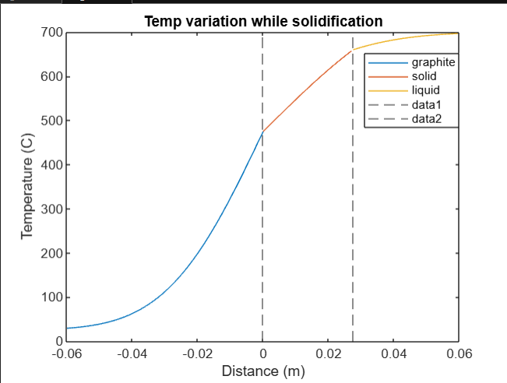

* **Simulation video for t=1 to t=20 seconds.**

% constants

T0=25; Tinf=700; Tf=660;

rhom=2200; rhos=2555; rhol=2368;

cpm=1700; cps=1190; cpl=1090;

km=100; ks=211; kl=91;

lf=3.98*10^5;

alpham=km/(rhom*cpm); alphas=ks/(rhos*cps); alphal=kl/(rhol*cpl);

ste=cps*(Tf-T0)/lf; %stefan constant

Tms = ( (T0*sqrt(km*rhom*cpm)*erf(0.522)) + (Tf*sqrt(ks*rhos*cps)) )/( (sqrt(km*rhom*cpm)*erf(0.522)) + (sqrt(ks*rhos*cps)) );

% Set the factor to slow down the animation

slow_down_factor = 100; % Increase this value to slow down the animation further

% Prepare video object

writerObj = VideoWriter('solidification_simulation.mp4'); % Specify the file extension explicitly

writerObj.FrameRate = 10; % Set frame rate (adjust as needed)

open(writerObj);

% Iterate through time steps

for t = 0:1:20

% Compute position and temperature at current time step

xpos = 2*0.522*sqrt(alphas*t);

xm = -0.06:0.001:0;

Tm = Tms+(Tms-T0)*erf(xm/(2*sqrt(alpham*t)));

xs = 0:0.001:xpos;

Ts = Tms+(Tf-Tms)*erf(xs/(2*sqrt(alphas*t)))/erf(0.522);

xl = xpos:0.001:0.06;

Tl = Tinf-(Tinf-Tf)*erfc(xl/(2*sqrt(alphal*t)))/erfc(0.522*sqrt(alphas/alphal));

% Plot

plot(xm, Tm); hold on; plot(xs, Ts); hold on; plot(xl, Tl);

legend('graphite','solid','liquid');

xlabel('Distance (m)'); ylabel('Temperature (C)');

title(['Temp variation while solidification, t = ', num2str(t)]);

fprintf('Interface position : %f\n', xpos);

% Add vertical dash lines

xline(0,'--');

xline(xpos,'--');

% Add frame to video multiple times to slow down animation

for j = 1:slow_down_factor

frame = getframe(gcf);

writeVideo(writerObj, frame);

end

end

% Close video writer

close(writerObj);